LOCATION : NATIONWIDE
DATE : 15.12.2017
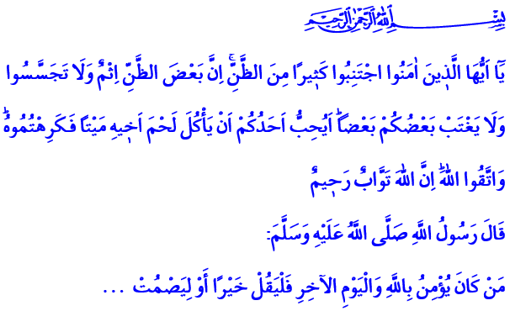
A DAGGER IN THE BACK OF BROTHERHOOD: BACKBITING
Blessed Friday to You, Honorable Believers!
One day, the Prophet’s (pbuh) wife Aishah implied that Safiyyah was short-statured. Thereupon, the Messenger of Allah pointed out how bad backbiting is with this warning: “O Aisha! You have said a statement which, if it were mixed in with the water of the sea, it would pollute it.”
Honorable Believers!
Backbiting is mentioning a brother or sister with unpleasant words. It is harming his honor and dignity in his absence. Backbiting is a dagger stabbed on trust and sincerity, peace and fondness, unity and solidarity; or in short, on brotherhood. It is an ugly attitude and behavior incompatible with humanity and unfitting for a believer, which harm the individual and society. Therefore, Lord Almighty has forbidden backbiting with this verse of the Quran: “O you who believe! Avoid much suspicions, indeed some suspicions are sins. And spy not, neither backbite one another. Would one of you like to eat the flesh of his dead brother? You would hate it. And fear Allah. Verily, Allah is the One Who accepts repentance, Most Merciful.”
Brothers and Sisters!
We are believers who are bound together with the brotherhood of faith. This is an unshakable brotherhood just like the building blocks of a structure that are fused to one another. In this brotherhood, the brothers are entrusted to each other. The life of our brother is our life. His honor and dignity is our honor and dignity. This brotherhood requires that we should not harm one another even with a seemingly small implication. This fact was articulated by one openhearted, gentle believer with this remark: “Never hurt a soul, or you’ll destroy the heavens of the Most Gracious.”
Honorable Brothers and Sisters!
During our daily lives, our minds get tired with all kinds of news. Our ears hear many words whether we want them or not. Especially in the mass media and social media, most of the time ugly words like gossip, lies and slander are presented in a way that arouses interest. Sometimes people’s honor and dignity are targeted by false news and comments that are senselessly and irresponsibly published. Yet our Prophet (pbuh) defined a Muslim as “the one who avoids harming others with his tongue and hands.”
Brothers and Sisters!
The Messenger of Allah (pbuh) enjoined us to stay away from behaviors that does not fit a believer like backbiting, suspicion and looking into others faults: “Do not back-bite Muslims, and do not search for their faults, for if anyone searches for their faults, Allah will search for his fault, and if Allah searches for the fault of anyone, He disgraces him even in his house.”
Our Master, The Greatest Prophet said: “Whoever believes in Allah and the Last Day should talk what is good or keep quiet.” He also informed us that it is enough falsehood for us to relate everything we hear.
Alas! Today, however, perception operations are put into place by people who turned lies, slander, backbiting and gossip into an industry. The peace and tranquility of the individual and the society are being greatly harmed with such negative behavior.
Dear Brothers and Sisters!
Let our tongue always move for trust confidence, peace and tranquility; not for sedition and malice. Let our words be uttered for loyalty and righteousness; not for gossip and backbiting or slander and lies. Let our speech lead to fondness and brotherhood; not hatred, grudge and enmity. Let us not forget that those who have a believer-like outlook on life and who protect their minds, hearts, tongues, hands and in short their bodies are the ones who would reach eternal blessings in that grand day.
I want to conclude the khutba with this prayer of our Prophet (pbuh):
“O Allah, indeed I seek refuge in You from the evil of my hearing, my sight, my tongue and the evil of my heart.”

At-Tirmidhi, Descr. of the Last Day, 51; Abi Dawud, General Behavior, 35.
Al-Hucurat, 49/12.
Al-Bukhari, Belief, 4.
Abi Dawud, General Behavior, 35.
Al-Bukhari, To make the Heart Tender, 23.
Abi Dawud, General Behavior, 80.
At-Tirmidhi, Chapters on Supplication, 74; Abi Dawud, Book of Prayer, 32. Written by: General Directorate of Religious Services

